Calculus Volume of Solids of Revolution

The formula for finding the volume of a solid of revolution around an axis is .

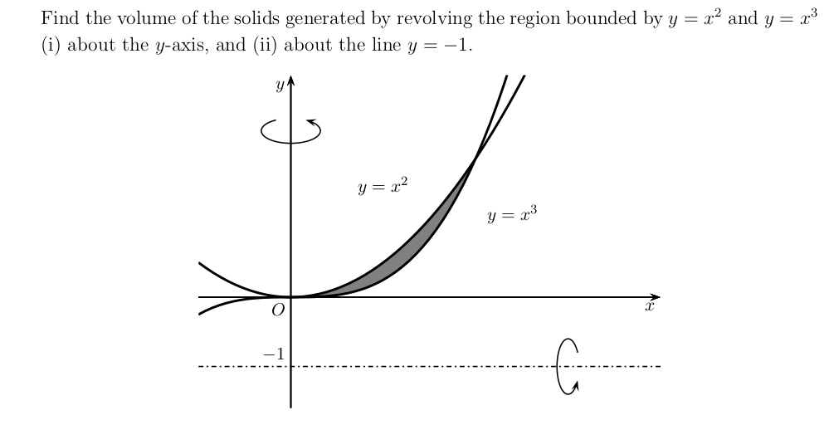
Consider this question:

The intersection points are and .

i) To revolve the region around the vertical axis, we need to represent the equations in terms of . The equations can be rewritten as and .

Volume:

ii) To revolve the region around the horizontal line , we need to represent the equations in terms of . The equations are and .

Also, the formula of the volume of a curve around a line is .

Volume:
Volume (Simplified):

